**Software Requirements Specification (SRS)  
Wireless**

# 1 Introduction

Every year, new automobile models are released with new and innovative features that require an ever­increasing amount of software. These embedded systems frequently communicate with each other, and oftentimes they do so through a gateway. This document describes the Generic Ethernet Gateway (GWAY). The GWAY is an on­board communications infrastructure that facilitates communication among the varied embedded systems within the vehicle and with external connections, such as diagnostic and reprogramming workstations.

This document begins by outlining the scope of the product and its purpose, then clarifies terminology. The document also gives an overview of the system, including product function characteristics and constraints. Additionally, an enumerated list of specific requirements divided into subsections are provided. To further clarify the requirements, visual models of the structure and behavior of the system are given. These models help provide a clearer understanding the system. Likewise, a description of how to run the prototype scenarios are contained in this document to visually capture observable behavior of the system. Lastly, a list of references and a point of contact will be included.

## 1.1 Purpose

The purpose of this document is to describe the specific requirements for the GWAY system. This document is intended to provide an unambiguous, concise, and complete list of requirements to help design the Ethernet Gateway. This document will include constraints and show how to use the system. The document is primarily intended for Mr. Anthony Torre of Chrysler Group LLC and any other personnel that will work directly with this system, as well as any stakeholders of the system.

## 1.2 Scope

The Generic Ethernet Gateway is a control system designed to allow communication between various embedded systems. More precisely, these messages can originate from CAN (Controller Area Network) ports or Ethernet ports, thus the gateway may need to convert protocols. Therefore the main goal of the system relies on facilitation of messages from one embedded system to another. Additionally, the gateway can conduct diagnostic tests on the system and reprogram the firmware of the gateway or any other connected system as needed. This allows for one point of entry or in this case, one port on the AVB (Audio Video Bridging) switch if firmware upgrades are needed.

Another goal of the system deals with security. Message packets inside the system must be encrypted to make sure an unauthorized person cannot hijack information on the gateway such as fault codes.

While the system shall perform various tasks listed above, there are a number tasks the gateway should not perform. First, the gateway cannot alter any of the data packets that it receives. The packets must be forwarded to the appropriate port number while keeping its data intact, however it may modify packet headers in case protocol conversions are required. Also, the system may not forward any unencrypted packets; all packets must be encrypted.

The use of a gateway comes with many benefits. One of the main benefits of a gateway system is that it greatly reduces the number of physical wires needed inside an application system. This is made possible by not requiring the many different systems to be interconnected with each other, but rather connected to a single gateway (Figure 1). As a result, Electronic Control Units (ECU) can have a single CAN interface rather than having digital inputs to every device in the system. This approach greatly reduces the complexity of electronic systems that, in turn, helps to reduce the cost and even the weight of the application domain. Moreover, new embedded systems can be easily connected to all other systems by simply connecting to a CAN bus. Additionally, the gateway can shut down ports if information coming from the ports seems irregular. For example, if a fault sensor keeps sending error­filled messages, the gateway can shut down the port to prevent unwanted noise from coming into the gateway.

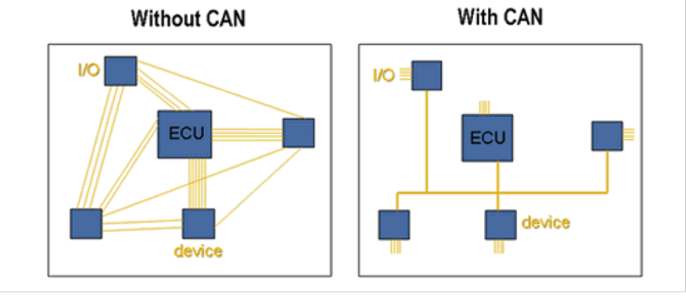

Figure 1: Benefits of use CAN networks. Source:[5]

There are various application domains for this system. This system can be used in aerospace, automotive industry, and even the military. Inside these entirely different application domains, the gateway is an embedded system that helps various other embedded systems communicate with each other. For example, inside an automobile or even an airplane, the sensor that senses cabin temperature can send a message to the air conditioning unit to turn on the fan.

## 1.3 Definitions, acronyms, and abbreviations

This section contains definitions of the acronyms, abbreviations, and specific terminology used in this document.

|  |  |
| --- | --- |
| AUTOSAR | A document that contains standards for automotive electrical systems. |
| AVB | Audio Video Bridging. Set of standard developed by IEEE that allows the transmission of audio and visual streams to be synchronized with each other with minimal latency. |
| Bridge | Connects networks with the same protocol (e.g CAN) and forwards messages from one network to another. |
| Bus | A medium that transfers data between different systems. |
| CAN | Controller Area Network. A serial bus network that connects multiple devices such as sensors and systems inside an automobile together. Speed of data transfer up­to 1 mbps. |
| CAN Bus | CAN Bus only transmits data on a CAN wire. |
| Database | A collection of data. |
| Denial of Service (DOS) | Occurs when information is coming in too fast into the gateway. This overloads the gateway that does not allow other systems to use the service of the gateway. |
| Ethernet | A wire that supports data transfer rates up to 100 mbps. Used in automobile to handle infotainment data and any other service that requires a large amounts of bandwidth. |
| Ethernet Bus | Ethernet Bus only transmits data on a Ethernet wire. |
| ECU | Electronic Control Unit. A general term given to an embedded system that controls and receives input from multiple systems. |
| Gateway | Interfaces with networks that use different protocols (e.g. CAN and Ethernet). It interconnects different networks by performing required protocol conversions. |

|  |  |
| --- | --- |
| GWAY | Generic Ethernet Gateway Project. The system being described in this SRS document. |
| IP | Internet Protocol. Each device has a unique IP address to allow for referencing. |
| IO | Input Ouput. Represents anything that might be a input or outpu of the system. |
| MBPS | Megabits­per­second. A rate of how fast data is transferred. |
| Noise | Unwanted information coming into the gateway from a port. |
| Packet | Contains chunks of data from a message. Multiple packets may be needed to transfer one piece of information. Information on the system data is in packets. |
| Port | A specific location on the gateway that allows systems to connect to the gateway. Each port has a unique IP address to allow for referencing. |
| RJ­45 | Another word for Ethernet cable. |
| SRS | Software Requirement Specification. A document that contains detailed information about the requirements of a system, its constraints and the goals. Required for being product development. |
| SQL | SQL is a programming language used to manage databases. |
| Sub­09 | A standard 9­pin electrical connector. |
| UML | Unified modeling language. A multiple purpose modeling language used to model requirements. |
| VLAN | A technology that allows layer two networks to be virtually segmented into separate broadcast domains. |

## 1.4 Organization

The rest of the document is broken down into six sections.

Section 2 contains the overall description. In this section, the document will provide information about the system functions. Also included in this section is a description of the constraints needed for safety, as well as any assumptions made in the user characteristics and dependencies.

Section 3 has a hierarchical enumerated list of the requirements the system must fulfill.

Section 4 contains various models that specify the bridge between application domain and machine domain. In this section, UML diagrams and their respective detailed explanations are used to visualize and demonstrate the expected behavior of the system.

Section 5 gives an overview of the prototype, describes how to access it and run it, as well as examples of sample scenarios.

Section 6 gives a list of all the references used to compile this document.

Section 7 gives a point of contact if more information is required.

# 2 Overall Description

This section serves to summarize the product, its major functions, characteristics, characteristics of its users, constraints, assumptions, and items that are outside of the scope of this project.

## 2.1 Product Perspective

The gateway can be used in multiple settings, including industrial, automotive, aerospace, and military applications. Wherever CANs are in use, the gateway facilitates inter­CAN communication and communications from non­CAN sources through Ethernet.

The gateway itself is a component connecting multiple networks. The gateway connects to up to six CANs and one AVB ethernet connection. The AVB ethernet connection may be a single device such as a diagnostic computer, or an AVB switch which aggregates multiple connections to the gateway. Gateway to CAN connections will use the D­Sub 9 terminator, and gateway to AVB Ethernet will use RJ­45 connections. At installation time, CAN ports must be enabled or disabled as needed per the application. The operating system environment for the gateway will include AUTOSAR [5], 1 MB of memory, and the most cost­effective commercial CPU available.

Figure 2.1 shows a common configuration of the gateway.

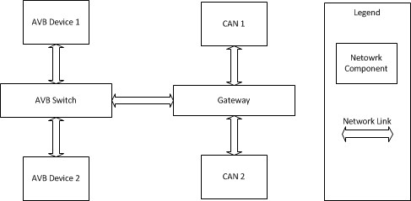

Figure 2.1: A sample block diagram of the gateway and connected components.

## 2.2 Product Functions

The primary function of the gateway is to perform message passing among the connected CANs and any device(s) connected to the ethernet port. For example, messages originating from “CAN 1” in Figure 2.1 may be routed to “CAN 2” or to any device connected to the AVB switch. The reverse is also true; any device connected to the AVB switch may send messages to nodes on CANs connected to the gateway.

The ethernet port will also facilitate upgrading the firmware of the gateway device or individual controllers on the CAN networks and performing diagnostics over IP. For example, in Figure 2.1, “AVB Device 1” may be a maintenance computer which could send a software update to the gateway. The gateway will apply the update and reboot.

The system will also respond appropriately to power conditions. The system will power on, power off, and reboot based on voltage levels supplied to the unit.

The gateway will also provide security features as required. This includes the administrative disabling of specific CAN ports and denial of service attack detection and mitigation.

## 2.3 User Characteristics

This product is not meant to interact directly with a consumer. In automotive applications for example, the driver of the vehicle would not knowingly interact with the gateway. Rather, many computer components of the vehicle will interact automatically with the gateway without the driver’s explicit knowledge. This is similar for pilots in aviation applications, operators in industrial applications, and crews in the military.

Persons working directly with the gateway include engineers and service technicians. Engineers responsible for implementing the gateway will have a deep understanding of the technologies the gateway interfaces with, and for those users, deployment and operation should be easily understandable. For technicians, operation of the gateway can be abstracted such that they need not be concerned with the inner operation of the device, but simply be cognizant that it exists as part of the communication chain.

## 2.4 Constraints

The following is a list of constraints for the system:

1. When input power dips below 6 volts, the gateway must reset itself to ensure correct operation.
2. The system must be capable of simultaneously handling nominal levels of traffic from all connected CAN and AVB nodes.
3. The system must be compatible with standard VLAN technology.
4. The gateway must conform to the following standards:
   1. ISO 13400: Diagnostics over IP
   2. ISO 14229: Storing tester interface information
   3. IEEE 802.1AS: Precise time synchronization
   4. IEEE 802.1Q: Traffic shaping for media streams
   5. IEEE 802.1BA: Identification of non­participating devices 5. All data in transit to and from the gateway must be encrypted.

## 2.5 Assumptions and Dependencies

The following assumptions have been made and will be true for the duration of the project:

1. AVB Ethernet standards will not be deviated from or adapted.
2. CAN communication standards will not be deviated from or adapted.
3. A standard encryption protocol and implementation will be selected and followed without deviation.

## 2.6 Approportioning of Requirements

The following features, functions, or issues are considered out of scope for this project:

1. Non­standard CAN messages or connections.
2. Non­standard AVB messages or connections.
3. Message manipulation beyond that required for routing messages.
4. Custom software for interfacing with the gateway.

# 3 Specific Requirements

There are a large number of requirements that the Gateway must meet. These requirements can be split up into requirements for operation, communication, diagnostics, and security, as detailed below.

1. Operations
   1. Main system memory will be at most 1 MB.
   2. The system will utilize the AUTOSAR Operating System.
   3. The system shall run on any low cost processor.
   4. The system shall facilitate 6 CAN ports, operating at 1 mbps and 1 Ethernet port.
   5. The Ethernet connection for the system shall have AVB functionality to allow for possible audio/video usage in the future.
   6. The system shall have a wake mode that will allow normal operation.
   7. The system shall have a sleep mode that it will enter when the power is turned

off.

* 1. The system shall have a restart mode.
  2. In a low voltage situation (below 6 volts), the system shall restart to avoid sending junk information.

1. Communications
   1. The system shall selectively read data from CAN ports, then re­transmit the data to the appropriate port in 8 byte packets with a time stamp over Ethernet, keeping latency at 1 ms.
   2. The system shall read data from the Ethernet port, parse and process it, and send specific desired responses to designated sources if necessary.
   3. The system shall permit reprogramming of ECUs on CAN ports.
   4. During reprogramming of the Gateway, all CAN ports should be disabled, with only the Ethernet port allowing data transfer.
   5. Reprogramming shall be separate from program memory, downloading the program into memory, then programming the flash sectors one at a time.
   6. CAN to Ethernet mapping on the Gateway should be done by IP.
   7. Message forwarding occurs on a cycle, handled by a timer.
2. Diagnostics
   1. The system shall allow a diagnostics program to be run through the Ethernet port, following the diagnostic guidelines in the ISO 14229 and AUTOSAR v4.1 documentation.
   2. Tester Interface Information shall be stored and read containing fault codes in 8 byte packets.
3. Security
   1. The system shall disable CAN ports that have higher than normal traffic (DOS Attack).
   2. The system shall allow the user to disable unused or unwanted CAN ports.
   3. The system shall use encryption to protect hijacking of messages or program specifics.
   4. The Ethernet port shall have VLAN compatibility, protecting from outside parties from writing to the system or gaining unauthorized access.

# 4 Modeling Requirements

This section contains various UML diagram to help showcase the functions of GWAY.

## 4.1 Use Case Diagram

A Use Case Diagram visually captures functions of the system. It shows the interaction between external actors on internal functions or use cases of the system. The system boundary helps to define the external actors and the internal functions. The extends signify another use case that is similar, with added functionality. Moreover, use case templates are provided to give detailed information for each use case of the system in the diagram. These templates show which actors are involved for a specific use case and shows the system requirement it satisfies.

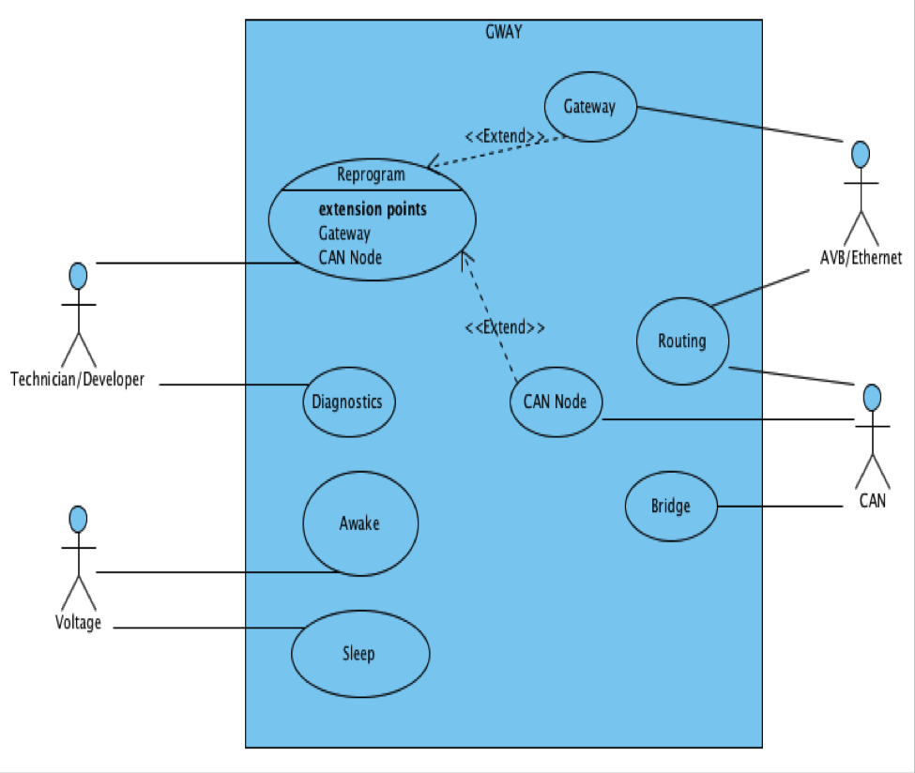

Figure 4.1 Use Case Diagram for GWAY.

|  |  |  |
| --- | --- | --- |
| **Use Case:** | | Awake |
| **Actors:** | | Voltage |
| **Description:** | | The system should start up when the system voltage threshold is above 6 volts. |
| **Type:** | | Primary |
| **Cross­refs:** | | 1.6 |
| **Use Cases:** | | All |
| **Use Case:** | | Sleep |
| **Actors:** | | Voltage |
| **Description:** | | The system should go into sleep mode when the system voltage threshold drops below 6 volts. |
| **Type:** | | Primary |
| **Cross­refs:** | | 1.7, 1.8, 1.9 |
| **Use Cases:** | | All but Awake |
| **Use Case:** | Diagnostics | |
| **Actors:** | Technician / Developer | |
| **Description:** | A technician retrieves the fault codes from the system which are stored in the database. | |
| **Type:** | Essential | |
| **Cross­refs:** | 1.5, 3.1, 3.2 | |
| **Use Cases:** | AVB/Ethernet, Routing | |
| **Use Case:** | Reprogram | |
| **Actors:** | Technician / Developer | |
| **Description:** | Reprogramming of the gateway and other embedded systems connected that are connected to the gateway. The developer connects to a port on the AVB switch that allows for reprogramming. | |
| **Type:** | Essential | |

|  |  |
| --- | --- |
| **Cross­refs:** | 1.5, 2.4, 2.5 , 2.6, 2.7 |
| **Use Cases:** | CAN, AVB/Ethernet, Routing |
| **Use Case:** | Gateway |
| **Actors:** | AVB/Ethernet |
| **Description:** | The gateway can be flashed with a new firmware by a technician. During this stage, all CAN ports are disabled. |
| **Type:** | Essential |
| **Cross­refs:** | 2.4, 2.6 |
| **Use Cases:** | Reprogram |
| **Use Case:** | CAN Node |
| **Actors:** | CAN |
| **Description:** | End systems that are connected to the gateway via CAN ports can be flashed with new firmware. |
| **Type:** | Essential |
| **Cross­refs:** | 2.3, 2.6 |
| **Use Cases:** | Reprogram |
| **Use Case:** | Routing |
| **Actors:** | AVB Ethernet, CAN |
| **Description:** | Messages encoded into packets are passed from the AVB Ethernet port to CAN ports and vice­versa. |
| **Type:** | Primary |
| **Cross­refs:** | 2.1, 2.2 |
| **Use Cases:** | Routing |
| **Use Case:** | Bridge |
| **Actors:** | CAN |
| **Description:** | Messages encoded into packets are passed from one CAN port to other CAN ports. These messages are encrypted and decrypted as well. |
| **Type:** | Primary |
| **Cross­refs:** | 2.1 |
| **Use Cases:** | Bridge |

## 4.2 Domain Model

The following section contains a domain model and a data dictionary for the system.

In the domain model, boxes represent logical objects within the system. Within the boxes, lines preceded with a “­” represent individual pieces of information that that particular object knows, and lines preceded with a “+” indicate actions a given object can perform. Lines connecting the objects show relationships among the boxes, and include a descriptive name and numbers representing how many of each object is involved.

Expanded information is provided in the subsequent section titled “Data Dictionary”.

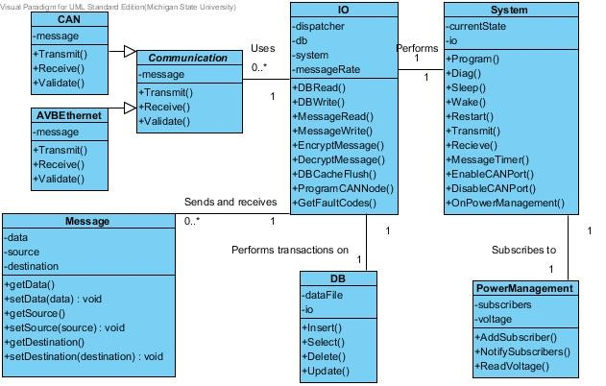

Figure 4.2: Suggested domain model for the generic gateway.

## Data Dictionary

The data dictionary provides additional detail for every element in the domain model.

|  |  |  |
| --- | --- | --- |
| **Element Name** |  | **Description** |
| System |  | Contains core functionality of the gateway, such as programming, power modes, and port control |
| **Attributes** |  |  |
|  | currentState : enum | Current state of the system:  reprogramming, normal, rebooting |
|  | io : IO | A pointer to an instance of the IO class to facilitate sending and receiving messages |
| **Operations** |  |  |
|  | Program() : void | Initiates reprogramming of the gateway |
|  | Diag() : void | Initiates diagnostic mode of the gateway |
|  | Sleep() : void | Puts the gateway in sleep mode |
|  | Wake() : void | Puts the gateway in normal/on mode |
|  | Restart() : void | Reboots/resets the gateway |
|  | Transmit() : void | Sends a message from the gateway to either a CAN bus or the AVB Ethernet port |
|  | Receive() : void | Receives messages from CAN bus of AVB Ethernet port |
|  | MessageTimer() : void | Handles timing interval for sending messages from the gateway |
|  | EnableCANPort(portnumber : int) :  void | Enables the specified CAN port |
|  | DisableCANPort(portnumber : int) : void | Disables the specified CAN port |

|  |  |  |
| --- | --- | --- |
|  | OnPowerManagement(voltage: int)  : void | Responds to change notifications from the PowerManagement class. |
| **Relationships** | The System class keeps a pointer to an instance of the IO class and  also subscribes to the  PowerManagement class. |  |
| **Element Name** |  | **Description** |
| IO |  | Controls input/output operations for the system |
| **Attributes** |  |  |
|  | db : DB | A pointer to an instance of the DB class |
|  | system : System | A pointer to a System instance for communication with the core gateway functions |
|  | messageRate : float | Rate at which messages are passing through the system |
| **Operations** |  |  |
|  | DBRead(statement : string) :  Message | Prepares a SQL statement to read data, interacts with the DB class, and receives response. |
|  | DBWrite(statement : string) : void | Prepares a SQL statement to write data to the DB, interacts with the DB class to insert the data |
|  | MessageRead() : Message | Reads a message from the  dispatcher, and interacts with the rest of the IO class to handle as needed |
|  | MessageWrite(message : Message) | Prepares a message to send out of the gateway and interacts with the communications class to send it. |
|  | EncryptMessage(message Message) : Message | Encrypts messages before they leave the gateway |
|  | DecryptMessage(message : Message) : Message | Decrypts messages after they are received by the gateway |

|  |  |  |
| --- | --- | --- |
|  | DBCacheFlush() : <vector>  Message | Interacts with the DB class to retrieve and send all messages that fit specific criteria for shipment to interfaces |
|  | ProgramCANNode() : void | Handles communication from AVB ethernet connections when reprogramming CAN nodes |
|  | GetFaultCodes() : void | Retrieves fault codes from the database when in diagnostic mode |
| **Relationships** | The IO class interacts with multiple instances of both the communication and Message classes, as well and keeping a pointer to an instance of the DB class |  |
| **Element Name** |  | **Description** |
| PowerManage ment |  | Monitors the system voltage and notifies subscribers of changes |
| **Attributes** |  |  |
|  | subscribers : <vector> | A list of subscribers to be notified of power events |
|  | voltage : int | Current system voltage |
| **Operations** |  |  |
|  | AddSubscriber() : void | Adds a subscriber to be notified |
|  | NotifySubscribers() : int | Sends a notification to subscribers that the voltage has changed |
|  | ReadVoltage() : int | Reads the voltage from the system |
| **Relationships** | Maintains a one­to­one relationship with the system class |  |
| **Element Name** |  | **Description** |
| DB |  | Handles interaction with the system database |

|  |  |  |
| --- | --- | --- |
| **Attributes** |  |  |
|  | dataFile : string | Path to the database file |
|  | io : IO | A pointer to the IO class, such that database triggers can initiate IO actions |
| **Operations** |  |  |
|  | Insert(record : string) : void | Inserts a record into the database |
|  | Select(parameters : string) : void | Selects records from the database based on given parameters |
|  | Delete(parameters : string) : void | Deletes records from the database based on provided parameters |
|  | Update(parameters : string) : void | Updates records in the database based on provided parameters |
| **Relationships** | Maintains a one­to­one relationship with the IO class |  |
| **Element Name** |  | **Description** |
| Message |  | Represents an individual message in the gateway, can be either a CAN or AVB Ethernet message |
| **Attributes** |  |  |
|  | data : string | Data of the message |
|  | source : string | Source address where the message came from |
|  | destination: string | Destination address where the message will be sent to |
| **Operations** |  |  |
|  | getData() : string | Returns the data of the message |
|  | setData(_data : string) : void | Sets the message data |
|  | getSource() : string | Gets the source address of the message |

|  |  |  |
| --- | --- | --- |
|  | setSource(_source : string) : void | Sets the source address of the message |
|  | getDestination() : string | Gets the destination address of the message |
|  | setDestination(_destination :  string) : void | Sets the destination address of the message |
| **Relationships** | Each message has a relationship with one IO instance, and each IO  instance may have many messages |  |
| **Element Name** |  | **Description** |
| Communication s |  | An abstract class for sending, receiving, and validating messages |
| **Attributes** |  |  |
|  | message : Message | The message to be sent, received, or validated |
| **Operations** |  |  |
|  | Transmit(message : Message) :  void | Pure virtual function for sending messages across the child class interface |
|  | Receive() : Message | Pure virtual function that returns a message to the IO class |
|  | Validate() : void | Pure virtual function that validates messages as they pass through the interface |
| **Relationships** | Dispatcher is an abstract class for the Bridge and Gateway classes, and the IO class may have many dispatchers. |  |
| **Element Name** |  | **Description** |
| CAN |  | A concrete derivative of the  Dispatcher class specialized for CAN |

|  |  |  |
| --- | --- | --- |
|  |  | bus messages |
| **Attributes** |  |  |
|  | message : Message | The message to be sent, received, or validated |
| **Operations** |  |  |
|  | Transmit(message : Message) :  void | Sends messages to CAN buses |
|  | Receive() : Message | Receives messages from CAN buses |
|  | Validate() : void | Validates messages from CAN buses |
| **Relationships** | The IO class may have many Bridge instances. |  |
| **Element Name** |  | **Description** |
| AVBEthernet |  | A concrete derivative of the  Dispatcher class specializing in AVB  Ethernet messages |
| **Attributes** |  |  |
|  | message : Message | The message to be sent, received, or validated |
| **Operations** |  |  |
|  | Transmit(message : Message) :  void | Sends messages through the AVB  Ethernet interface |
|  | Receive() : Message | Receives messages from the AVB Ethernet interface |
|  | Validate() : void | Validates messages to and from the AVB Ethernet interface |
| **Relationships** | The IO class may have many Gateway interfaces |  |

### 4.3 Sequence Diagrams

The following sequence diagrams show a layout of how the system handles the different use case scenarios previously detailed. Time flows downward vertically, with the objects represented along the top.

#### 4.3.1 ­ CAN to CAN Communications

When a CAN port relays information to the system, the Bridge object will receive the message. It will then check if it is a valid message to be forwarded to another location on the system. The Bridge will then send the message to the IO object, where it will be read and decrypted, parsing it into data, source, and destination. The IO object will then write the message to the database, calling functions from the Database object to store it. Once stored, the IO object reads from the database, re­encrypts it, and converts it back into proper message format. Lastly, the message is transmitted back to the Bridge object to be sent to the proper CAN destination port.

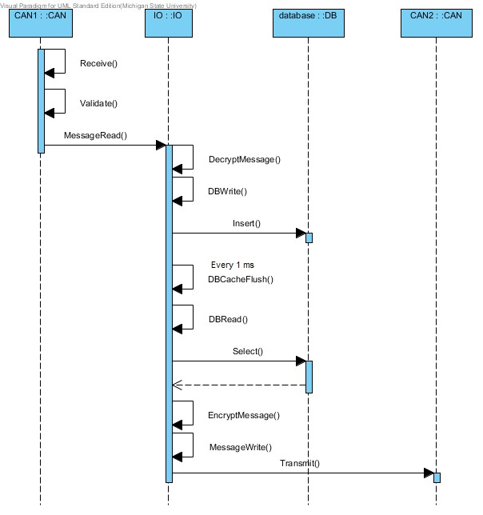

Figure 4.3.1: Sequence diagram for CAN to CAN communications.

#### 4.3.2 ­ CAN to Ethernet Communications

CAN to Ethernet communications behave the same as CAN to CAN communications, however, the destination will be specified as the Ethernet port instead of a CAN port. So instead of transmitting the message back to the Bridge at the end, the message will be sent to the Gateway object.

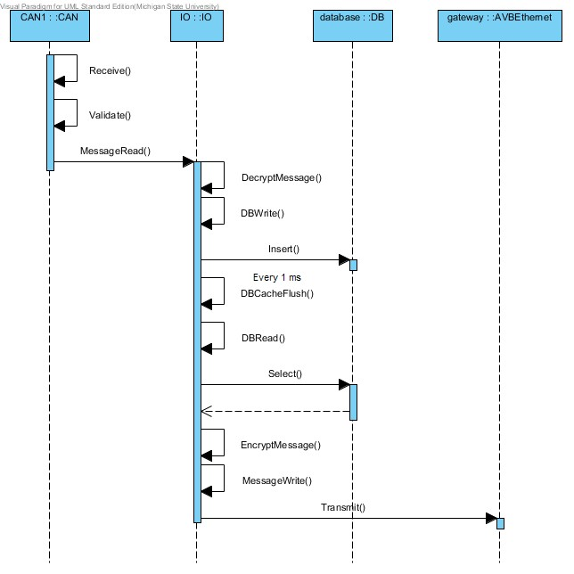

Figure 4.3.2: Sequence diagram for CAN to Ethernet communications.

#### 4.3.3 ­ Ethernet to CAN Communications

Ethernet to CAN communications behave the same as CAN to Ethernet communications, however, the message originates from the Ethernet port, so the starting object is the Gateway instead of the Bridge and the destination is the Bridge instead of the Gateway.

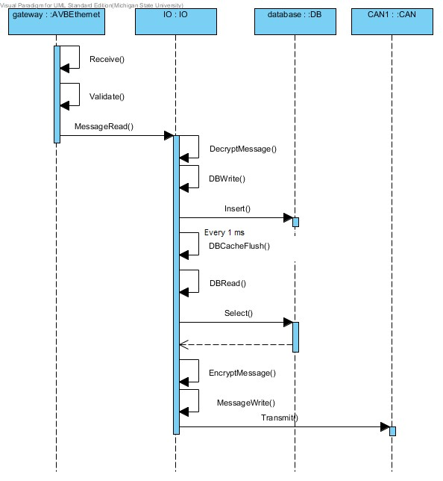

Figure 4.3.3: Sequence diagram for Ethernet to CAN communications.

#### 4.3.4 ­ Reprogramming the Gateway

Information from the Ethernet port will be received on the Gateway object, and the message will be sent to the I/O object and read, then decrypted. The System object then programs the system and disables all CAN ports. The System then restarts.

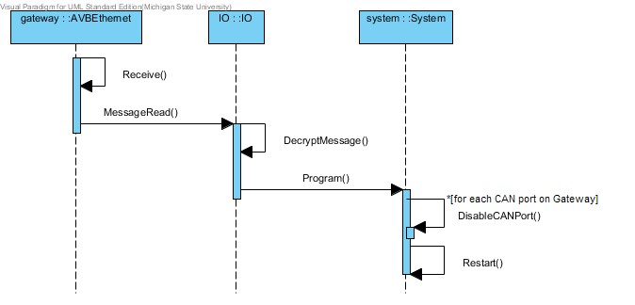

Figure 4.3.4: Sequence diagram for reprogramming the Gateway.

#### 4.3.5 ­ Reprogramming CAN ports

Information from the Ethernet port will be received on the Gateway object, and the message will be sent to the I/O object and read, then decrypted. The System object then programs the specified CAN nodes with the information from the message.

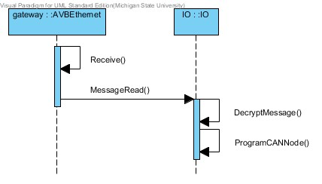

Figure 4.3.5: Sequence diagram for reprogramming a CAN port.

#### 4.3.6 ­ Diagnostics

Information from the Ethernet port will be received on the Gateway object, then sent to the I/O object, where it will retrieve messages from the database using the Database object. The messages are read from the database and sent back to the Gateway in the same manner that messages are sent in other types of situations.

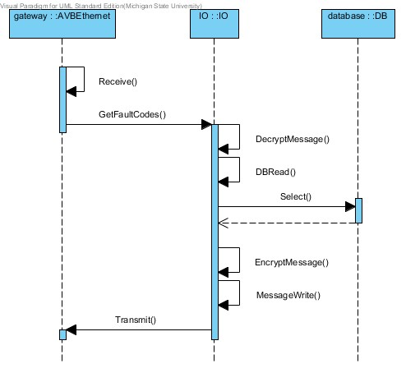

Figure 4.3.6: Sequence diagram for diagnostics.

#### 4.3.7 ­ Low Voltage

Once the system is on, the System object will initialize an observer pattern to monitor the power level of the system using the Power Management object. The Power Management object consistently checks the voltage of the system, and notifies the System object when it drops below 6 volts. In such a case, the system will then enter sleep mode.

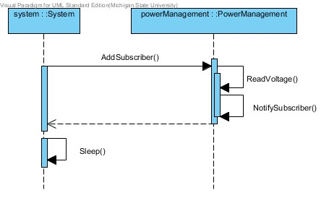

Figure 4.3.7: Sequence diagram for low voltage monitoring.

### 4.4 State Diagram

The figure 4.4 shows all possible states and transitions for the gateway. States are marked using a round­edged box with a short description of the state. State transitions are signified using arrows with text descriptions. These descriptions generally consist of a function call and any constraints that need to be met before the transition is made. Constraints are indicated using brackets. The starting state of a diagram is indicated using a black dot pointing to a state.

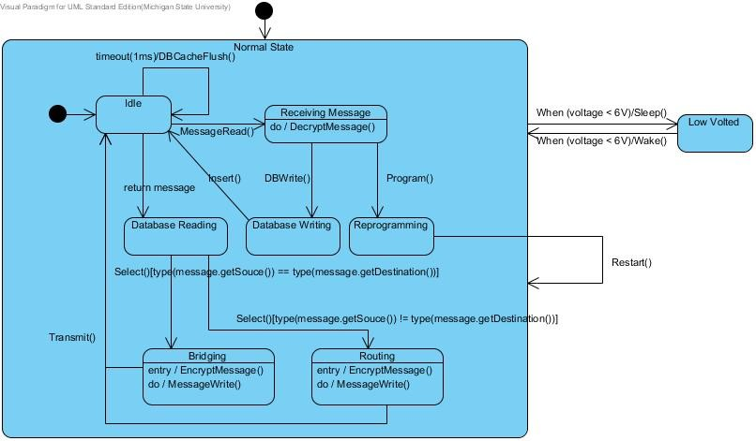

Figure 4.4: State diagram for the gateway.

# 5 Prototype

The prototype visually simulates what happens on the system in different scenarios. Operation of the gateway can be visualized using seven basic scenarios: data transfer, low voltage, shutdown port, reprogram CAN node, reprogram gateway, IP diagnostics, and denial of service. Each scenario corresponds to each button on the control box.

## 5.1 Prototype Operation

To run the prototype, a modern web browser with HTML5 and JavaScript support must be used. Supported browser are: ● Firefox – 2.0 +

* Safari – 3.0 +
* Chrome – 4.0 +
* IE – 9.0 +

This prototype has not been tested on mobile devices and cannot be guaranteed to run on them. The first version of the prototype can be acessed at http://www.cse.msu.edu/~cse435/Projects/F2013/Groups/GWAY/Prototype/prototypev1.html. The second version is currently under development and will be available soon.

## 5.2 Sample Scenarios

The operation for each specific example scenario is detailed below.

### 5.2.1 Data Transfer

The user can specify which ports send and receive the message with the drop downs above the scenario buttons. After the user clicks the “Transfer Data” button, the data packet (yellow square) starts from the source node (CAN port 3), goes through the database, and finishes at the destination (AVB port 1).

The status of the system is also updated as “Selectively read data from the source CAN port, and retransmit the data to the appropriate destination in 8 byte packets with a timestamp, and route it via IP to the specified AVB node”.

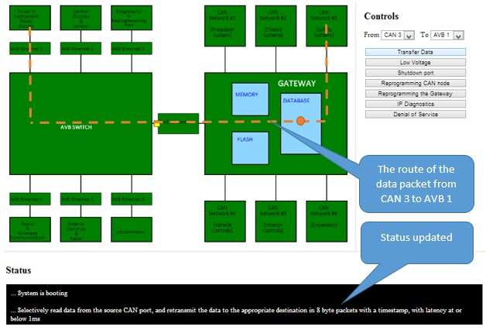

Figure 5.2.1: Transferring data from CAN port 3 to AVB port 1.

**5.2.2 Remaining supported scenarios:**

Status of the system will be updated on the Status Console in different scenarios:

* Low voltage:

"Low voltage threshold detected (>6v), system shutting down. System is off."

* Shutdown port:

"Can port <number> has been shut down." ● Reprogramming CAN node:

"Can node reprogrammed.

* Reprogramming the Gateway:

“Image is being copied to the gateway…

Image is being copied to flash…

Gateway is rebooting…” ● IP Diagnostics:

"Fault codes from the database are being forwarded to the IP diagnostics endpoint." ● Denial of Service:

“Too much traffic is being received from a node on CAN <number>, denial of service detected, shutting down CAN port <number>.”

# 6 References

1. Sys Tec Electronic. “CAN­Ethernet Gateway V2”. [Online] http://www.systec­electronic.com/en/products/industrial­communication/interfaces­and­gateway s/can­ethernet­gateway­v2 (Accessed: 23 September 2013).
2. Lucia Bello, “The case for Ethernet in automotive communications”, 2012, University of

Catania, Italy, http://sigbed.seas.upenn.edu/archives/2011­12/Keynote.pdf

1. Prototypes V1 GWAY, 26 Oct, 2012,

http://www.cse.msu.edu/~cse435/Projects/F2013/Groups/GWAY/Prototype/prototypev1.html

1. “Controller Area Networks Overview”, November 30, 2011, National Instruments,http://www.ni.com/white­paper/2732/en/
2. “AUTOSAR”, Internet: http/www.autosar.org/index.php?p=3&up=1&uup=1&uuup=0 [November 4, 2013]

# 7 Point of Contact

For further information regarding this document and project, please contact **Dr. Betty H.C. Cheng** at Michigan State University (chengb@cse.msu.edu). All materials in this document have been sanitized for proprietary data. The students and the instructor gratefully acknowledge the participation of our industrial collaborators.